Name:  Class: | ____________________________________  ________________ |  | Date:_________
 | Year 11 Foundations Mathematics  /47  5 %  Test 2 2020  Data and Graphs
Total Time: | 55 minutes
Weighting: | 5%
Equipment: | To be provided by the student: Pen, pencil, ruler,1 double sided A4 page of notes, scientific calculator

Describe the following types of data as either Numerical or Categorical. [5]
- The number of cookies sold each day.

- The brands of shoes people wear.

- The number of pizzas delivered an hour

- The speed that cars travel in a school zone.

- The favourite colour of each person in our class.

Q2. Using the graph on the right as a guide, Answer the following questions:
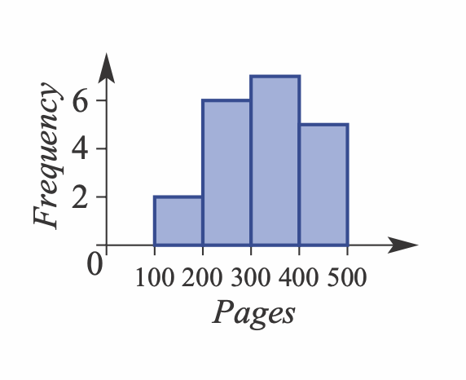
- How many books have more than 300 pages

- How many pages is the most common?

Q3. On the electricity bill below, fill in the key features of the graph that are missing.
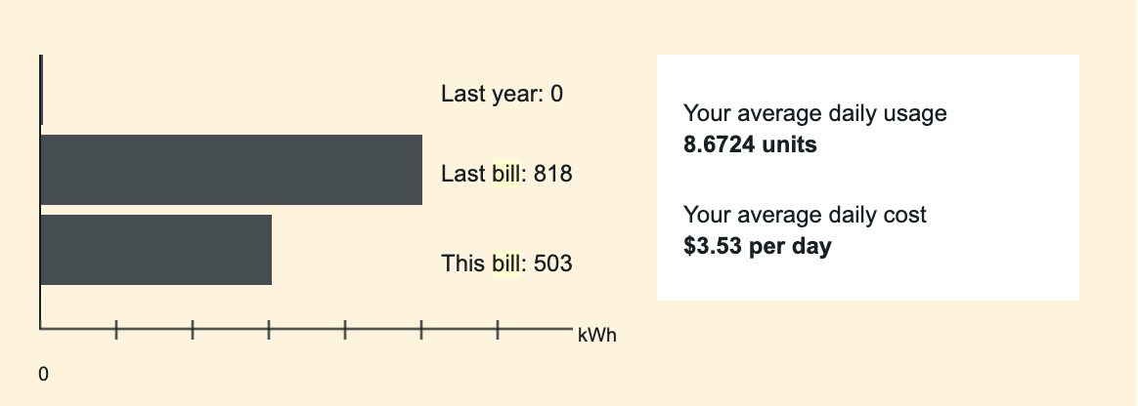

Q4. The Two way table shows the numbers of people in a group who use emails and/or internet banking.

 | Email | No Email | Total
Banking | 12 | 2 | 14
No Banking | 6 | 11 | 17
Total | 18 | 13 | 31

  - How many people are in the group?

  - How many people in the group don’t use either internet banking or email?

  - How many of the group use both email and internet banking?

  - Calculate the number of people who use email.

  - Does the information support the statement that most people who use internet banking also
use email? Use values to support your answer.

Q5. The City of Rockingham has an annual budget of $156,088,469, gained from the following sectors.
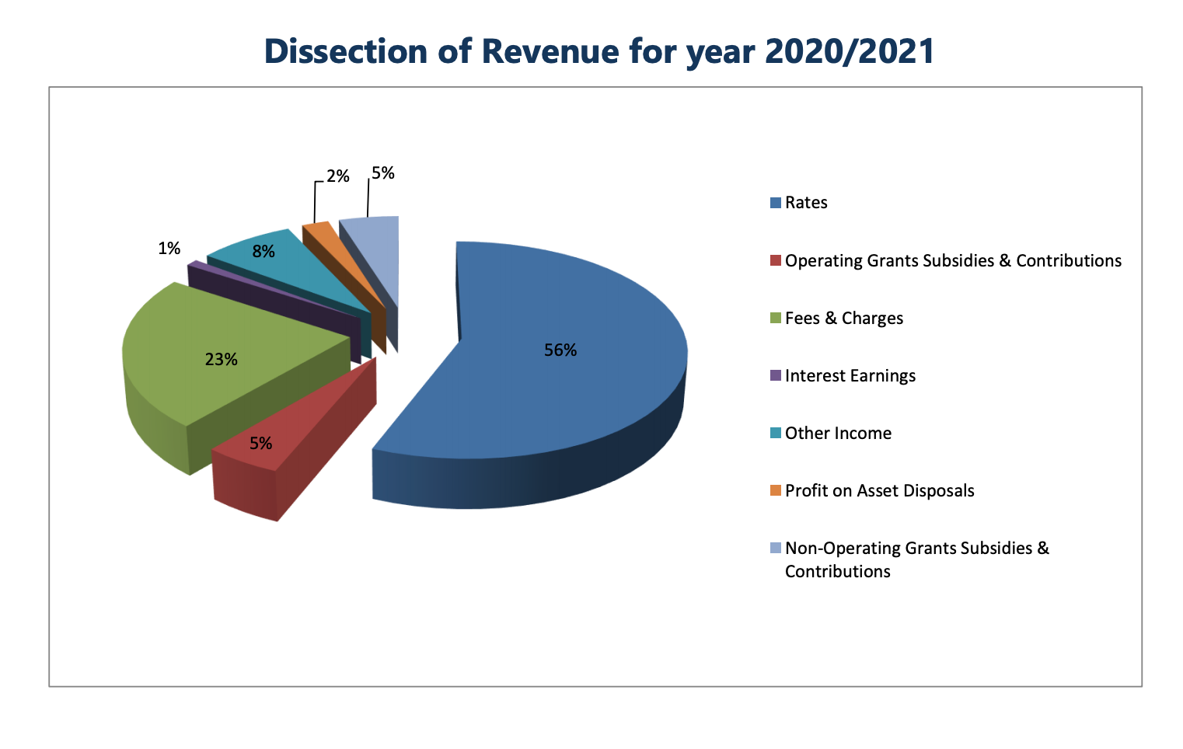
- Work out how much each sector of the pie is worth.
Sector | $ Amount
Rates
Operating grants
Fees and Charges
Interest Earnings
Other income
Profit on assets
Non – Operating grants

Q6. Using the data below, Create an appropriate graph of the information.

Type of doughnut | Number sold Monday | Number sold Friday
Plain | 250 | 170
Cinnamon | 185 | 220
Iced | 278 | 150
Cream-filled | 110 | 180
Chocolate | 140 | 113
Fancy | 87 | 201


